Solution

Q.2a)

Suppose that a data warehouse consists of the four dimensions, date, spectator, location, and game, and the two measures, count and charge, where charge is the fare that a spectator pays when watching a game on a given date. Spectators may be students, adults, or seniors, with each category having its own charge rate.

(a) Draw a star schema diagram for the data warehouse.

(b) Starting with the base cuboid [date, spectator, location, game], what specific OLAP operations should one perform in order to list the total charge paid by student spectators at GM Place in 2010?

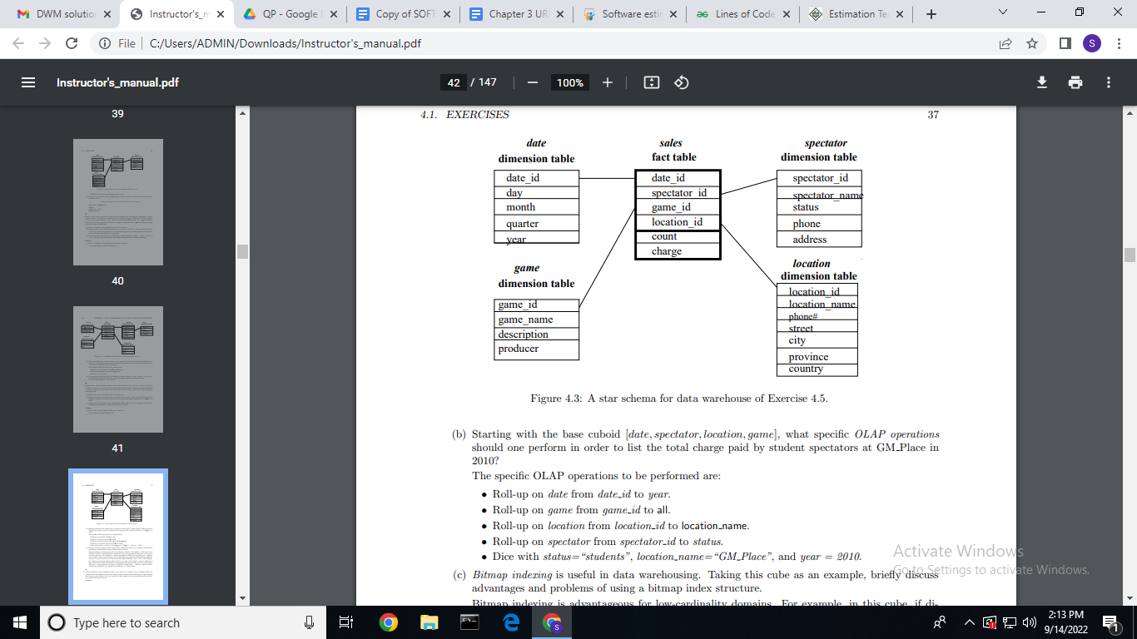

Data Pre Processing:

<https://www.geeksforgeeks.org/data-preprocessing-in-data-mining/>

Data cleaning:

<https://www.javatpoint.com/data-cleaning-in-data-mining>

Data Transformation:

<https://www.javatpoint.com/data-transformation-in-data-mining#:~:text=Data%20transformation%20is%20a%20technique,data%20into%20the%20appropriate%20form>.

**Comparison between:**

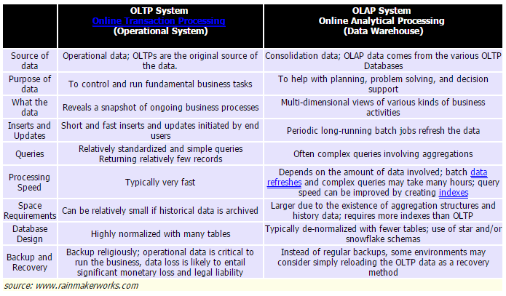

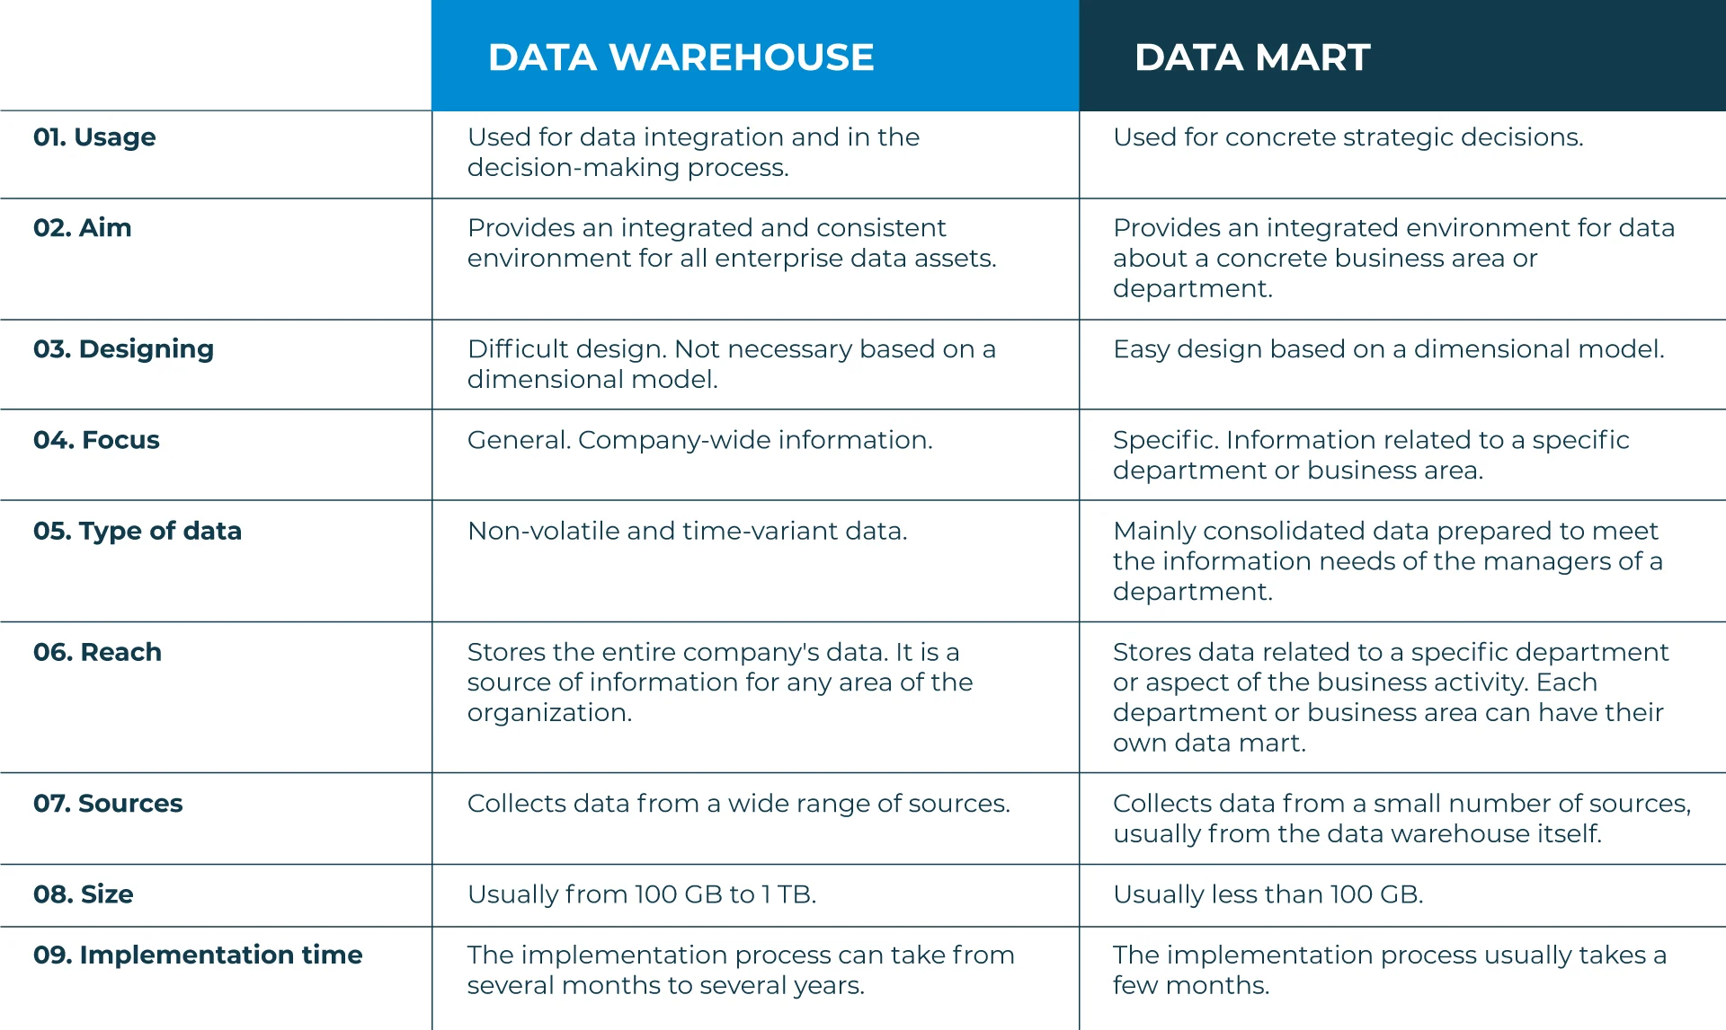

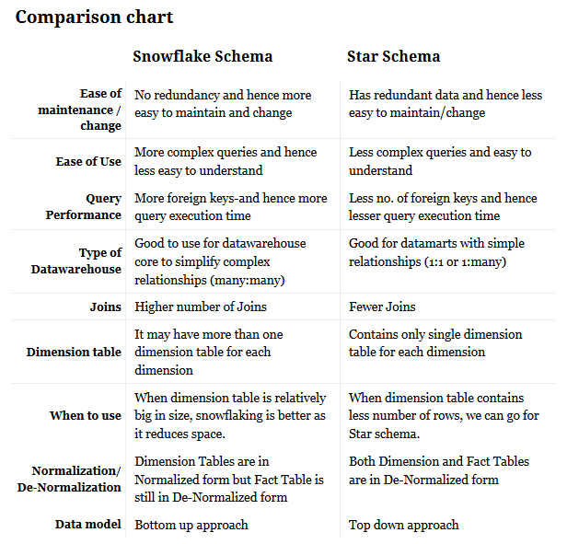

**Fact Constellation**

<https://www.geeksforgeeks.org/difference-between-snowflake-schema-and-fact-constellation-schema/>

Data Pre Processing

